COMMUNICATION
INTRODUCTION
Communication is the act of conveying information for the purpose of creating a shared understanding. It’s something that humans do every day. In other words, communication is the activity of conveying information through exchange of thoughts, messages or information as by speech, visuals, signals, writing or behavior. The term ‘communication’ has been derived from Latin “communis” which means common. So, communication is an act by which a person shares the knowledge, feelings, ideas, information, etc., in ways such that each gains a common understanding of the meaning, intent and use of the message. Thus to communicate means is to make common or to make it known, to share and it includes verbal as well as non-verbal means of human interaction. Communication requires a sender, a message and a recipient. Communication requires that the communicating parties share an area of communicative commonality. The communication process is complete once the receiver has understood the message from the sender. It also means a meaningful exchange of information between two and a group of people. Communicative competence designates the capability to install inter-subjective interactions, which means that communication is an inherent social interaction. Basically, communication is sharing information, whether in writing or orally.

WHAT IS COMMUNICATION
In a layman’s term, communication is the sharing of information. It is the giving and receiving of messages.
Brooker (1949) says communication is anything that conveys meaning, which carries a message from one person to another.
Hovland(1964) says communication is the process by which an individual, the communicator, transmits (usually verbal symbols) to modify the behavior of other individuals-receivers.
Saloman (1981) states that communication in its wider sense is a process whereby people convey knowledge, influence each other, and create and maintain a basis of shared notions.
Ellis and Beattie (1986)assert that communication occurs when one organism (the transmitter) encodes information into a signal which passes to another organism (the receiver) which decodes the signal and is capable of responding appropriately.
Keyton (2011) Communication can be defined as the process of transmitting information and common understanding from one person to another.
The above definitions underscore the fact that unless a common understanding results from the exchange of information, there is no communication.
Communication is a process whereby information is enclosed in a package and is channeled and imparted by a sender to a receiver via some medium. The receiver then decodes the message and gives the sender a feedback. All forms of communication require a sender, a message, and an intended recipient; however the receiver need not be present or aware of the sender’s intent to communicate at the time of communication in order for the act of communication to occur. Communication requires that all parties have an area of communicative commonality. There are auditory means, such as speech, song and tone of voice, and there are non-verbal means, such as body language, sign language, eye contact, through media, i.e. pictures, graphics and sound and writing. The act of communicating draws on several interpersonal and intrapersonal skills. These include speaking, listening, observing, questioning, processing, analyzing and evaluating.
Thus communication is a two-way process that results in a shared meaning or common understanding between the sender and the receiver.
Harold Laswell described a communication system as:
WHO
Say WHAT
In which CHANNEL
To WHOM
With what EFFECT

Characteristics of communICATION
Some of the characteristics of communication are as follows:
- Communication is a bipolar process. One person speaks or writes and the other person listen or read.
- It is also a psychological process as emotions are also made to be understood by communication along with ideas and facts.
- Communication is a purposeful process which involves sources, messages, channels and receivers.
- Communication occurs everywhere intentionally or unintentionally.
- Communication is a continuous and comprehensive process. This means that speaking listening and understanding, all three activities go together. If any of these activities stops, then communication will stand still.
- Communication involves interaction-the give and take that provides feedback to persons involved in exchanging ideas.
- Communication is an instinctive process. So no prior assessment of the process is possible.
- Communication can be written, oral and symbolic. Immediate feedback is possible in case of oral communication.
TYPES OF COMMUNICATION
Communication may be broadly classified into two types:
- Verbal communication
- Non-verbal communication.
Verbal communication: Verbal communication may be written, oral, intra-personal, inter-personal and public communication.
- Written communication- In written communication, words are the most important means of communication. Words are not only used to express facts, thoughts and ideas, but also attitudes, feelings and emotions towards people object and events. Written communication refers to messages which are expressed on paper through words or pictures such as graphs, diagrams, models etc. Written communication does not provide the benefits of immediate feedback and it tends to be expensive and time consuming.
- Oral communication- Oral communication may be through face-to-face interchange or over telephone, etc. its main advantage is that it provides feedback and creates a personal touch among the persons.it helps in making communication more effective and it promotes better understanding of ideas and intentions.
- Intrapersonal communication- Intrapersonal communication refers to communication with oneself. The communication is within the self and to the self, e.g. thinking, working out a problem, writing diaries, hearing one speak. Intrapersonal communication continues as long as a person is alive.
- Interpersonal communication- Interpersonal communication means communication between at least few people who interact face to face like a telephonic conversation, interview, talking to friends etc.
- Public communication- Public communication takes place in situations where many people receive messages largely from one source. Say for example, a movie, television show sermon, political speech, advertiser’s message, religious leader’s lecture committee report etc.
Non-verbal communication: In this type of communication, instead of using words only symbols are used. The receiver of the message necessarily knows these symbols, so he reacts to them at proper time.
- Raising hand by the teacher to instruct the students to keep quiet and sign language etc. are few examples of non-verbal communication.
- Von-verbal communication describes the process of conveying meaning in the form of non-word messages. Some forms of non-verbal communication includes chronemics, haptics, gesture, body language or posture, facial expression and eye contact, object communication such as clothing, hairstyle, architecture symbols tone of voice as well as an aggregate of the above.
- Speech also contains non-verbal elements known as paralanguage. These include voice quality, emotion and speaking style as well as prosodic features such as rhythm, intonation and stress.
- Likewise written texts include non-verbal elements such as handwriting style, spatial arrangements of words and the use of emoticons to convey emotional expression in pictorial form.
ELEMENTS OF THE COMMUNICATION CYCLE
The communication cycle is the process by which a message is sent by one individual, and it passes through a chain of recipients. The timing and effectiveness of a communication cycle is based on how long it takes for feedback to be received by the initial sender.
Understanding the educational process depends upon understanding the communication process. Communication is a complex concept that requires considerable reflection as to its nature and mode of transmission. The basic communication model involves an information or interpretative process in which messages, information or reaction to information travel from the initiator to the receiver through the route called “communication channel”.
The basic communication model consists of 5 elements of communication:
1. Sender/ Source
2. Receiver
3. Message
4. Channel
5. Feedback
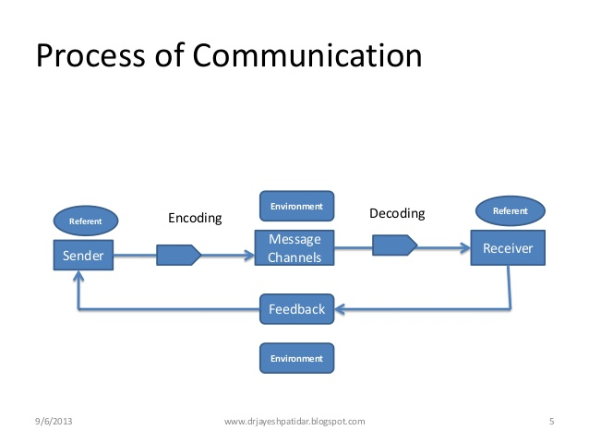

In communication process, a sender (encoder) encodes a message and then using a medium/channel sends it to the receiver (decoder) who decodes the message and after processing information, sends back appropriate feedback/reply using a medium/channel. It can be diagrammatically represented as follows:

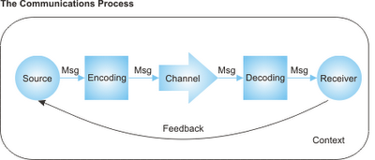

SENDER/SOURCE: This is technically called the encoder. It is a person or a thing or event which provides verbal or non-verbal cues to which someone can respond. The sender plays the specific role of initiating communication. To communicate effectively, the sender must use verbal as well as non-verbal techniques
Receiver: It is the person who interprets a message sent by a source. The receiver means the party to whom the sender transmits the message. A receiver can be one person or an entire audience of people.
Message: These are set of verbal or non-verbal cues sent by the source/sender. Messages can be written or spoken, gestures, movements, etc. the message may be the most crucial element of effective communication. The message is not necessarily what the sender intends it to be. Rather, the message is what the receiver perceives the message to be.
THE channel: Channel is the means or medium used to convey the stimuli. The message travels from one point to another via a channel of communication. The channel sits between the sender and the receiver.
FEEDBACK: The last element of effective communication, feedback, describes the receiver’s response or reactions to the sender’s message. The receiver can transmit feedback through asking questions, making comments or just supporting the message that was delivered. Feedback helps the sender to determine how the receiver interpreted the message and how it can be improved.
BARRIERS IN COMMUNICATION
Most people would agree that communication between two individuals should be simple. When you communicate, you are successful in getting your point across to the person you're talking to. It’s important to remember that there are differences between talking and communicating. When we talk, we tend to erect barriers that hinder our ability to communicate.
Some of the communication barriers during conversation include:
- Semantic barrier
- Presentation barrier
- Personal barrier
- Emotional barrier
- Physical barrier
- Organizational complexity barrier.
Let us now discuss them in brief.
Sematic barrier: Such barrier are created due to language related mistakes such as
- Using a particular word in the message with different meaning at different places.
- Using a sentence which may have more than one meaning.
- Using highly technical words in the message.
- Using too many phrases and proverbs.
- Having lots of grammatical mistakes
- Using long and complicated sentences and paragraphs.
Presentation barrier: This barrier arises if there is any fault in the organizational structure of the message such as:
- Including too many facts and information in one paragraph.
- Lack of logical sequence among different facts and information.
- Preparing the whole message without heading or sub heading.
- Objectives of communication not clear at all before the sender.
Personal barrier: These barriers are especially related to either sender or receiver such as:
- If there is no proper rapport between the sender and the receiver, they will not be able to understand each other.
- If the source of the message is not reliable.
- If the receiver is not sensitive to the message, then miscommunication will be created.
- Lack of motivation on the part of the receiver will lead to miscommunication.
Physical barrier: These barriers are related to physical conditions and environment of the sender and the receiver such as:
- Communication is also affected a lot by noise to distractions.
- Lack of proper lighting at the time of written or non-verbal communication.
- If there is any defect in the equipment used for communication.
- Fatigue on the part of the receiver.
- Physical distractions are also there such as, poor lightning, uncomfortable sitting, unhygienic room also affects communication in a meeting.
Emotional barrier: Emotional state at a particular point of time also affects communication. If the receiver feels that communicator is angry he interprets that the information being sent is very bad. While he takes it differently if the communicator is happy and jovial (in that case the message is interpreted to be good and interesting), such as:
- Mood of the sender at the time of sending the message.
- Mood of the receiver at the time of receiving the message.
Complexity in Organizational Structure: Greater the hierarchy in an organization (i.e. more the number of managerial levels), more is the chances of communication getting destroyed. Only the people at the top level can see the overall picture while the people at low level just have knowledge about their own area and a little knowledge about other areas.
HOW TO COMMUNICATE EFFECTIVELY
Communication skills are the set of skills that enable a person to convey information so that it is received and understood. It is essential to know the following ways in order to have effective communication. It is important to know the ‘who what why when and how’ of communication. It means who you are communication with, what you are communicating, what the goal of your communication is (what you want to achieve), when you will communicate the issue and how you will communicate the issue.
CLASSROOM COMMUNICATION
Basically, the process of education consists of a transaction between teacher and student. Teaching may be considered as a sort of communication. The teacher I supposed to communicate new ideas, attitudes, information, behavior, skills, etc. Teacher’s communication will be fruitful only when students receive and understand it and learn it. Here the teachers are senders of communication and students are the receivers. Salomon (1981) suggested that education depends upon acts of communication. Education is a collaborative experience which depends upon acts of communication. In the present times education cannot be a one-way transmission of information because in one way transmission of instructional setting, it may be regarded as indoctrination and this is a serious problem if educationist to be seen as a collaborative experience.
Mere presentation of message or a lesson by the teacher is communication but it cannot be effective unless it leads to true learning. Good teaching is more than communication.it is not merely enough for the student to merely repeat the same word as conveyed. The student should be able to make a permanent and meaningful addition to the students own communication skills. Classroom communication is not mere one-sided presentation of facts; it requires inter-communication between student and teacher. There needs to be interaction with constant reciprocal feedback.
Classroom communication exists in three categories: verbal, non-verbal and written. Verbal communication means anything that a teacher or student speaks aloud. Non-verbal communication refers to body language that people express. Written communication refers to directed at a specific audience, such as report card comments or student assignments. Teachers and students interact with one another in many different contexts, and use all three of these types of communication. Since communication is an interactive process it is very close to teaching. Success of teaching lies in the success of communication.
Barriers to Effective Classroom Communication
If learning is to be effective then it should be ensured that the communication process travels along a channel and clear of interference. To do this the teacher should know what the barriers in classroom communication are. The following are some of the barriers in classroom communication.

- Lack of effective listening is one of the most important barriers.
- Perception of different people receiving and hearing the same message but interpreting it differently.
- Language can also be a barrier if the teacher and the students don’t speak the same language
- Excessive verbalism means when the teachers talks too much in the classroom.
- Day dreaming on the part of the students happens when the classroom teaching is not interesting.
- Physical discomfort of the students like inconvenient chairs and desks, poor lighting, lack of fresh air etc.
- Cultural differences can be a barrier if messages are delivered in a way that is comfortable to all. Since common understanding or ground is required to be established among people of different cultures to cultivate an open, positive attitude towards one another.
FACTORS WHICH LEAD TO EFFECTIVE CLASSROOM COMMUNICATION
Some of the factors which can lead to effective classroom communication are as follows:
- Using of best teaching strategies: Teaching is an art. The teacher has to use the best of the teaching strategies in order to make his teaching effective and for students to be able to give him the feedback. Being a dictator in the classroom or too much verbalism by the teacher, inability of the teacher to control the class etc. will hamper the good communication in the classroom. Thus the audience or receiver should be as active as the communicator to have a sustained reciprocal communication.
- Using proper technology: Nowadays there are so many audio visual media at disposal and the teacher should use them to improve the communication in the classroom.
- Effective use of feedback: True communication is achieved through potent and insistent feedback. Good feedback means immediacy, regularity, explanatory conciseness and clarity.
- Effective two way communication: Good teaching should facilitate a two way communication process because it plays a crucial role in the educational process.
- Development of motivation: A teacher needs to employ both verbal and non-verbal communication in the classroom setting to bring about effective teaching. Creating a congenial environment in the classroom promotes a positive student attitude and achievement and motivates the student. Even a smile and an encouraging tone is enough to motivate a student.
- Principle of clarity: Knowledge of teacher has to be integrated with information and the teacher should have clarity in his communication to express his intention. A strong voice, sound knowledge, a good communicator and facilitator is the essential quality of a teacher
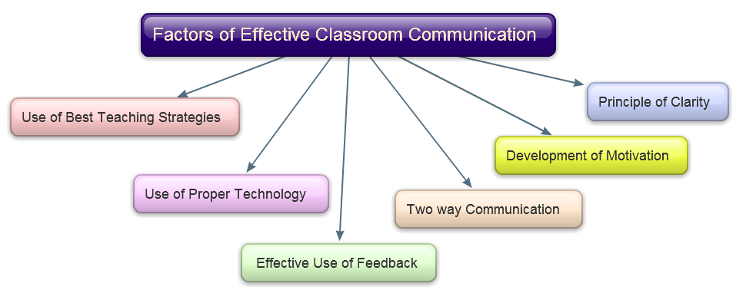
CONCLUSION
In today's globalized, media-driven world, communication studies have become more relevant and exciting than ever. Web developers seek new, inventive ways to draw Internet users to their websites. Public policy writers debate society's most pressing issues. Through linguistics, computer scientists are developing programming languages that may someday allow humans to interact directly with computers. Students who earn degrees in communication often hold highly influential positions as journalists, editors, university professors, public relations officers, marketing consultants, speech writers, filmmakers, motivational speakers and political campaign managers. To communicate is to shape the world. So, it may be concluded that communication is a process of social interaction. In a communication situation, two or more individuals interact. They try to tangibly influence the ideas, attitudes, knowledge and behavior of each other. Communication is thus an exchange of information, knowledge, ideas or feelings taking place between two individuals. But in a face to face situation, the gestures, expressions, language and tone, create an impact on communication. A number of barriers retard effective communication. To improve the effectiveness of communication, schools must develop awareness to the importance of sender’s and receiver’s responsibilities and also adhere to active listening skills. Thus in conclusion we can say that communication is the process of sharing information, thoughts and feelings between people through speaking, writing or body language. Effective communication extends the concept to require that transmitted content is received and understood by someone in the way it was intended. The goals of effective communication include creating a common perception, changing behaviors and acquiring information.

OBJECTIVES

The main objectives of this chapter are to acquaint the students about:
- the different characteristics of communication;
- the types of communication;
- the elements of communication cycle;
- the barriers in communication; and
- the factors which leads to effective classroom communication.

GLOSSARY
1)Non-verbal communication: Non-verbal communication refers to body language that people express.
2)Verbal Communication: Verbal communication means anything that a teacher or student speaks aloud.
3)Barriers: Barriers can be any form of disturbance that disrupts the free and successful interchange of ideas and message between the sender and the receiver.
4)Classroom Communication: Every action of the teacher, the directions being given by the teacher, be it his lecturing, asking questions, recapitulating, assignment, homework etc. all continuously influence the learner and thus is included in classroom communication.
5)Interpersonal Communication: Interpersonal communication means communication between at least few people who interact face to face like a telephone.

FAQs
1. What is communication?
Ans: Communication is an act by which a person shares the knowledge, feelings, ideas and information.
2. Name some barriers of communication.
Ans: Some common barriers of communication are excessive verbalism, day dreaming, physical discomfort, confusion, language problem etc.
3. What are the components of communication?
Ans: The components of communication process are sender, message, medium and receiver.
4. What is the basic communication process?
Ans: The basic or simple communication process involves a sender delivering a message to a receiver who listens to or reads it, and then offers feedback to the sender.
5. What is communication cycle?
Ans: The communication cycle is the process by which a message is sent by one individual and it passes through a chain of recipients.

REFERENCES
M,Vandana, 2010: A Textbook on Educational Technology, Sanjay Prakashan, New Delhi.
Sachdeva, M.S.2006: Essentials of Educational Technology and Management, 21st Century Publications, Patiala.
Sachdeva, M.S.2013: Teaching Learning: Process and Evaluation,Tandon Publications, Ludhiana.

